# Accessible Resources Check List

## Text

* Font is Sans Serif type (Arial, Calibri) with 12 pt. minimum for written documents, 20pt minimum PowerPoint.
* Use **bold text** rather than underline or italics to emphasise text.
* Limit block capitals to BLACKCAPS & WHITEFERNS (see explanation 1.2).
* Heading styles in MS Word are used to format docs rather than changing the visual appearance (see explanation 1.5).
* Left alignment used.
* Tables are formatted correctly as per explanation 1.6.
* Colour contrast between text and background is 4.5:1 (see explanation 1.8).

## Images

* Meaningful alt text provided for all images that contain useful/necessary information. This includes graphs, flow charts and diagrams.
* Alt text is not necessary for decorative images.
* Images used reflect the range of people involved in the game (age, gender, ethnicity, ability).

## Links

* Hyperlinks are descriptive at the end of the text as often as practical e.g. “visit the [smash play website](https://play.nzc.nz/programme/smash-play-junior-tamariki)” rather than “[click here](https://play.nzc.nz/programme/smash-play-junior-tamariki) to visit the Smash Play Website”.
* Links do not automatically open in a new tab unless they have to (i.e., they are within a coaching module or document). If a link needs to open in a new tab, this is communicated e.g., the info is in brackets (new tab). See explanation 3.3 to understand this.
* If a resource is a PDF, there is a html (webpage) version or MS Word version available too.

## Video

* Videos have informative descriptions.
* Subtitles/closed captions are available.
* If there is no voice over in a video (and therefore no CC), there is alt text available to explain what is happening in the video.

## Language

* Resources are written in plain language as much as possible. See point 5.1.
* Language is gender neutral.
* Te reo is used appropriately.
* Use language that respects disabled people as active individuals with control over their own lives e.g., wheelchair user **not** wheelchair bound. See explanation 5.2.

# Explanations

The following provides explanations as to why things are accessible/not accessible. This resource was developed using Blind Low Vision New Zealand Guidelines and the MSD Accessibility Guide, along with other resources linked within this document.

# Text

## Italics

Avoid using italics.

With some typefaces, the italic letters are different from the regular letters. The characters are usually thinner and more ornate, making them more difficult to read.

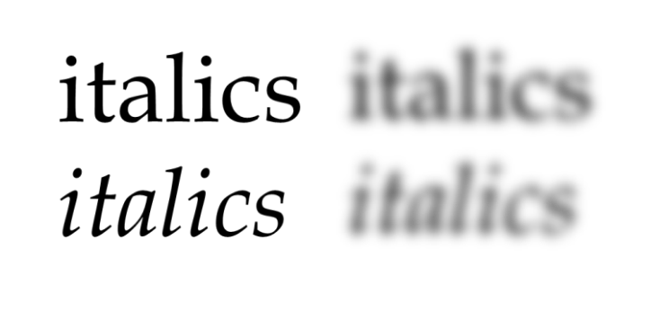

## Block Capitals

Avoid using block capitals. (BLOCK CAPITALS)

There are different theories as to why we find capitalised text difficult to read. In 1886 James Catrell came up with the idea that we use word shapes which help to identify words.

Regardless of the theories, capitalized text is considered harder to read because we are not used to reading in all caps. Also, many regard capitalised text as shouting. These are the primary reasons for avoiding all caps text.

## Underlining

Avoid using underlining. Limit it to links only.

Underlining text can create problems due to the cross over with the "descenders” of the characters (the bits of g, y, j, p and q that hang down below the baseline)

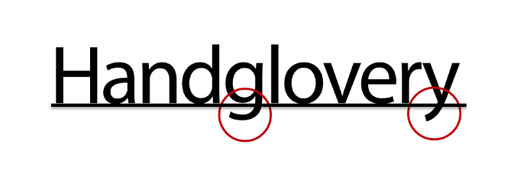

## Bold

Use **bold text** to emphasize text without reducing readability.

## Heading Styles

Use Heading styles to format Microsoft Word documents

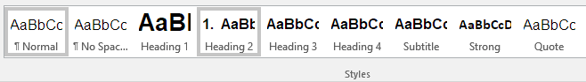

A good heading structure is **probably the most important accessibility consideration** in most documents.

Headings must be formatted using styles in Word, rather than simply changing the visual appearance of the text by making it bigger or applying bold.

Styles are not an accessibility tool; it is how Microsoft meant for you to format documents. It is the most efficient method of formatting documents.

While there are many styles within Word, screen reader users only use the Heading styles for navigation.

Marking headings correctly means that…

* You can use features in Word that rely on heading codes, like adding a table of contents, creating hyperlinks automatically and using the Navigation Pane.
* Screen reader users can use headings to navigate using the headings as a list of contents to scan the document
* The document can be converted into an accessible PDF file, braille, large print, and synthetic audio more quickly and efficiently.

**Note:** Styles can be modified by right clicking (or using the context menu key) and selecting **Modify**. These changes will affect every instance of the style throughout the document. If you modify a heading, it will still be readable by a screen reader.

## Tables

Avoid using merged cells as they can make navigation using a screen reader very confusing. While technically accessible, a table used for layout can be difficult to comprehend using a screen reader. For example, the table below is read out as...

"Non-uniform table, "Title" row 1 of 3 column 1 of 2, "Date" Column 2 of 2, "Name" row 2 of 3, number of columns changed from 2 to 3, "Code" column 2 of 3, "Currency" column 3 of 3, "Address" row 3 of 3 column 1 of 3, "Country" column 2 of 3, "Reference" column 3 of 3"

|  |  |  |  |
| --- | --- | --- | --- |
| **Title** | | | Date |
| Name | Code | | Currency |
| Address | | Country | Reference |

Changing this table so that it is **small, simple and symmetrical** will make this table easier to comprehend and navigate. The following table will be easier to navigate.

| **Form** | **Details** |
| --- | --- |
| Name |  |
| Date |  |
| Currency |  |
| Address |  |
| Code |  |
| Reference |  |

Avoid using blank rows and columns as they can be interpreted as the end of a table. Tables with blank areas can also be difficult to navigate to find data even if the information is accessible.

Screen readers read tables from left to right. For example, in the table below it would be read out as "Basement up toilets flush" not "Basement toilets flush up"

| Basement |  |  | up |
| --- | --- | --- | --- |
| toilets |  | flush |  |

Each line of information in a table should have its own row. The table below shows a table with 2 rows, however there is multiple lines of text in the cells in row 2. This would read out as "Maths, English, Physics" then "Tuesday, Monday, Friday" and finally "10:00, 12:00, 10:30"

| **Class** | **Day** | **Time** |
| --- | --- | --- |
| Maths  English  Physics | Tuesday  Monday  Friday | 10:00  12:00  10:30 |

The following table has correct formatting; each line of information has its own table row.

| **Class** | **Day** | **Time** |
| --- | --- | --- |
| Maths | Tuesday | 10:00 |
| English | Monday | 12:00 |
| Physics | Friday | 10:30 |

## Alignment

Left align text. Avoid using centred headings and mixing text alignment.

Mixing text can cause information to be entirely missed. Below shows a recipe with the headings centred at normal magnification.

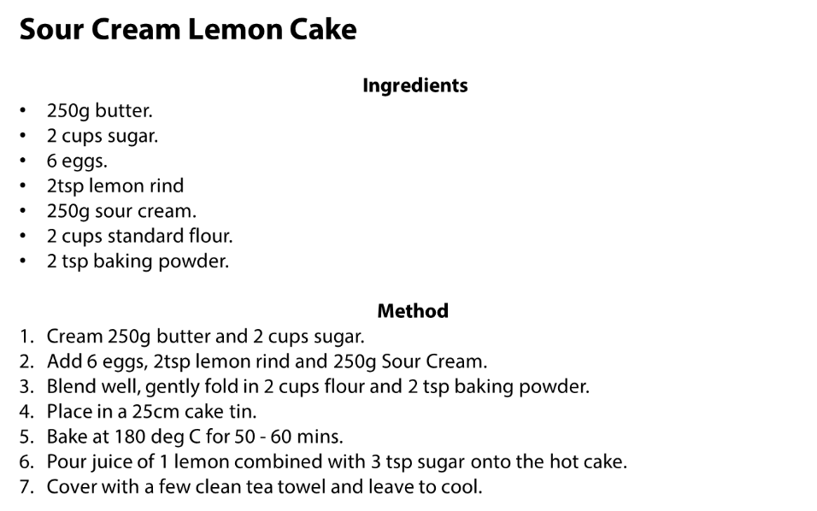

The same recipe is shown below with magnification, and as a result the centred headings are off to the right of the screen and could be difficult to find.

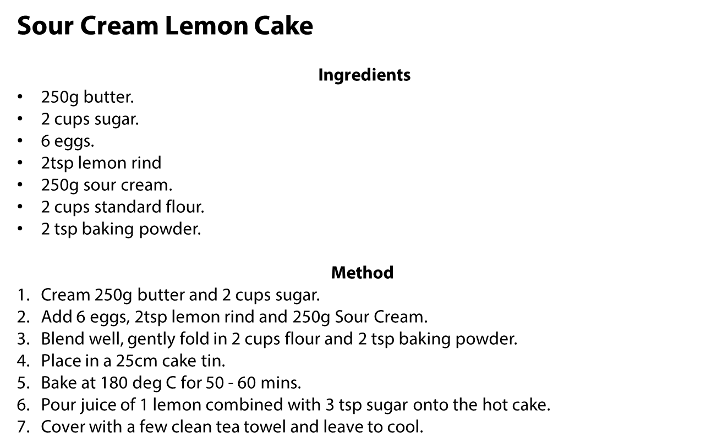

## Colour Contrast

It is usually obvious if a contrast is easy to read or not, but we can effectively measure colour contrast with the [Web AIM Contrast Checker](https://webaim.org/resources/contrastchecker/). Enter the brand colour HEX number from our brand guidelines. Example below of Smash Play Branding.

This provides a pass/fail assessment against international standards (Web Content Accessibility Guidelines). Although the tool is primarily for assessing screen accessibility, it is an effective tool for documents intended for print too.

# Images

## Alt Text

Alternate text (or alt text) is required for screen reader users to access text equivalents in place of the image. A text equivalent does not require a full description of every detail. A good way to think of alt text is to imagine you are describing the image to someone over the phone.

Alt text is different from a caption, as the alt text is read out when the screen reader gets to the image. A caption may not be in the right reading order, and it may not be clear the caption is referring to the image.

### Alt text example



**Too little**: Dog

**Just Right:** Sam the guide dog puppy runs through the field

**Too much**: Sam the golden Labrador guide dog puppy wearing a red coat running towards the camera through a field of grass with two types of daisy.

### How to Add Alt Text to Images in Microsoft Word and Outlook

1. Right click image
2. Select **Format Picture…**
3. **Click Layout and Properties (square box with arrows) and** Select **Alt Text**
4. Fill out **Description**

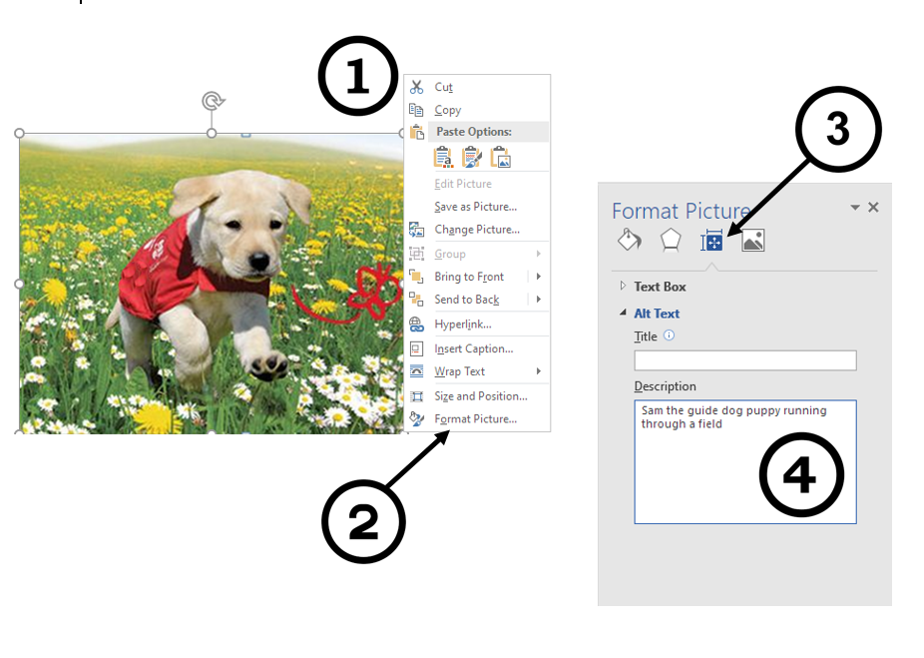

## Images Must Be "In Line with Text"

The Wrap Text properties of an image change the relationship between the text and the image. For the alt text to work, the image needs to set to ‘in line with text’ (see picture below). This does limit the placement features of word, but a screen reader is unable to pick up the alt text details if this option is not used.

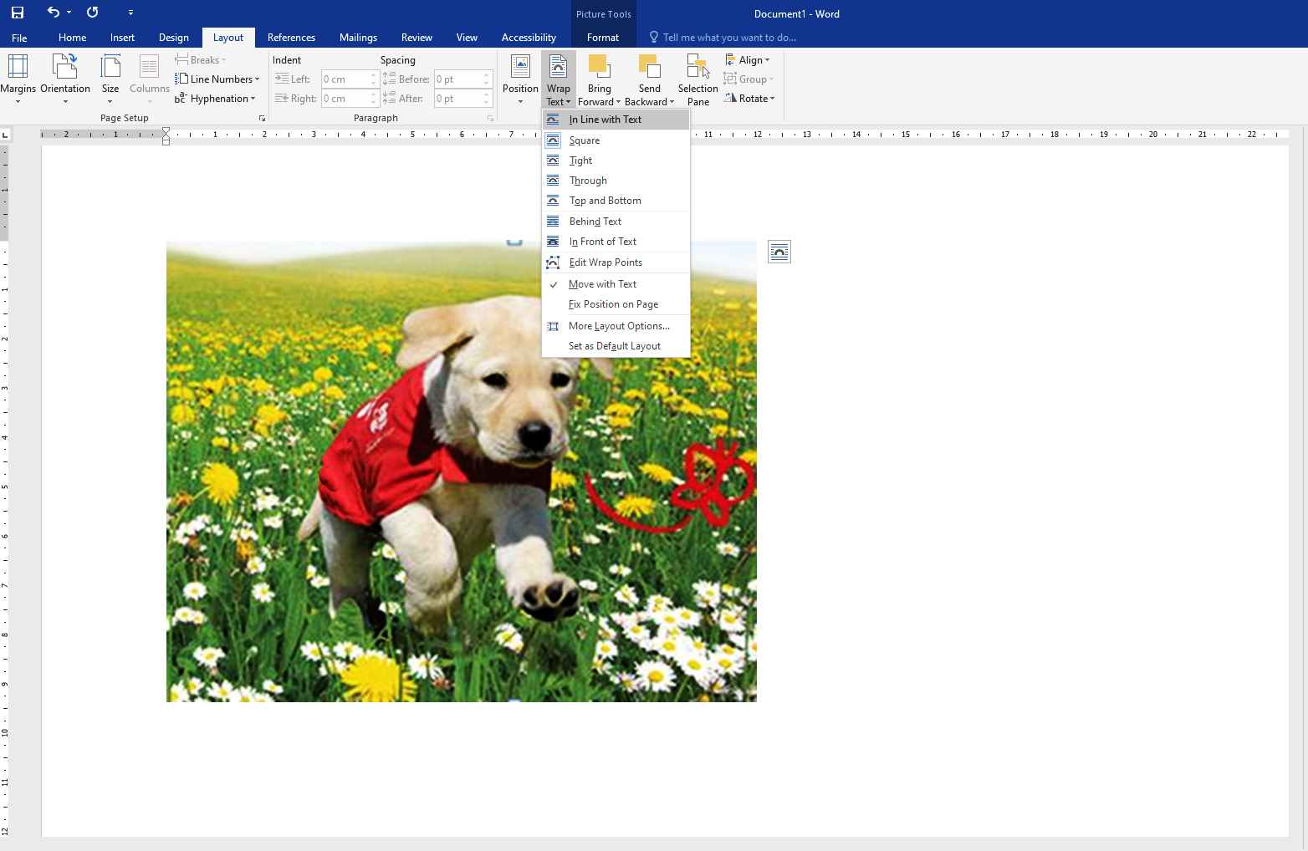

## Graphs, Flow Charts and Diagrams

All graphs, flow charts and diagrams require a text or tactile equivalent.

Graphs, flow charts and diagrams can be difficult to describe with text. With graphs, include a simple table of data that will be able to be read by screen readers. In some cases, a bulleted list can be used for a simple chart. If the image is complex, consider creating a tactile copy for blind people and those with low vision.

## Text Boxes

Do not use text boxes in Microsoft Word. Screen readers cannot access text boxes in Word. For similar reasons to why images must be inline, screen readers simply cannot read the content in a text box or a shape with text in it.

# Links

## Use descriptive hyperlinks

Hyperlinks are used as a form of navigation for screen reader users. How they are formatted can affect the accessibility of a document. It is important that link text is descriptive and makes sense. For example:

**Do:** Visit the [smash play website](https://play.nzc.nz/programme/smash-play-junior-tamariki)

**Don’t:**  [Click here](http://www.hrc.govt.nz/) to visit the Smash Play website.

## Links to print resources

Users should generally be alerted to links that lead to non-HTML resources, such as PDF files, Word files, PowerPoint files, and so on. However, there is some debate as to whether the content author or the browser should be the one to alert the user. The trouble is that none of the browsers or screen readers currently alert the user at all, so the debate is more theoretical than practical.

A link to a PowerPoint slide show, for example, could say:

[Smash Play Youth Rangatahi Game Formats (PowerPoint)](https://play.nzc.nz/programme/smash-play-junior-tamariki) or something similar,

and a link to a PDF file could say: [Keep up and play game (PDF)](chrome-extension://efaidnbmnnnibpcajpcglclefindmkaj/https:/play.nzc.nz/sites/default/files/2023-03/Game%20Sheet_FC_Keep%20Up%20%26%20Play%20v1.pdf) or something similar.

## Links in new tabs

There is much debate about the merits of links that open in new windows, pop-up windows, or other frames. Some people would like to ban them entirely. Others concede that they can be appropriate at times, but nearly everyone agrees that users **ought to be alerted** when the link does not open in the current window or frame. The accessibility issue is that some

users can get confused with the new windows or tabs. Then when they try to click on the Back button in the browser, nothing happens, because there is no previous link to go back to in a new window or tab.

It is up to the authors to alert the users. Authors can add this information to links by placing it in parenthesis at the end of the link, for example by saying

View the [Aktive Good Sports Resource (opens new window)](https://aktive.org.nz/resource-hub/)

**Note: ensure what is in the brackets is included in the link**

e.g. **Not** [Keep up and play game](chrome-extension://efaidnbmnnnibpcajpcglclefindmkaj/https:/play.nzc.nz/sites/default/files/2023-03/Game%20Sheet_FC_Keep%20Up%20%26%20Play%20v1.pdf) (pdf)

**Not** [Aktive Good Sports Resource](https://aktive.org.nz/resource-hub/) (opens new window)

* 1. **PDF**

If you are uploading a resource in PDF, provide the MS Word version or an HTML (webpage) as well. An example of offering a PDF and HTML version can be seen on the [Sport NZ Youth Voices page](https://sportnz.org.nz/resources/youth-voices-in-active-recreation-and-sport/).

PDFs are often **not** automatically accessible by assistive technologies unless converted from an accessible word doc in the first place (and even then, can have issues).

PDFs are accessible when they are correctly tagged. Tags provide assistive technologies with an outline or structure of the PDF that can help interpret the content and the reading order of the document to their users. This outline is hidden from sighted viewers unless they open the tag sidebar menu. Adobe’s built-in automatic tagging is not perfect, and even though you can edit tags within Adobe Acrobat, the process is challenging and not user-friendly, hence uploading the Word version is a simple way to ensure the resource is accessible to more people.

# Videos

## Captions

Provide captions (also called “subtitles”) so that people who are Deaf and hard-of-hearing get a text version of the speech and non-speech audio information needed to understand the content.

## Description of Visual Information

Provide descriptions so that people who are visually impaired can adequately get the visual information needed to understand the content.

# Language

## 5.1 Plain Language

Documents should have a Flesch Reading score of 60 (Plain Text).

The Flesch Reading Ease measures textual difficulty, which indicates how easy a text is to read. This measure does not measure the complexity of the subject; it measures how difficult a piece of text is to read. By factoring aspects such as word length and syllables, a numerical value is given. **The higher the score the easier it is to read**.

There is a built-in tool to measure Flesch reading ease in Microsoft Word. However, it is not set by default. Follow these instructions below to set it to check your document by default.

1. Select File tab
2. Select Options
3. Select Proofing
4. Check Show readability statistics checkbox

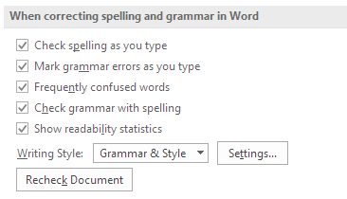

### Tips for Plain English writing

* Split long sentences into shorter ones.
* Target complex words and replace with two-word combinations.  
  E.g., ‘establishment’ into ‘setting up.’

## 5.2 Disability Language

In New Zealand we use the term disabled people as per the New Zealand Disability Strategy.

The reasoning was that:

* people are people first
* they have particular impairments or conditions, that is, they are people with impairments e.g. a person with a vision impairment, or a hearing loss, or limited mobility.
* **attitudinal and physical barriers in the world we all live in disable them**
* therefore, they are disabled people or, more accurately, **people disabled by the way we build and organise our world**. 'Disabled' refers to things outside the person that impact on them and put barriers in the way of their participation.

There are more examples of which terms are preferred on the [MSD Website](https://www.msd.govt.nz/about-msd-and-our-work/work-programmes/accessibility/quick-reference-guides/disability-language-words-matter.html) and in the Paralympics NZ [Para sport terminology guide](https://paralympics.org.nz/about/para-sport-terminology-guide/).

The Understanding Disability Toolkit from [Aktive](https://aktive.org.nz/resource-hub/) is useful too.

This resource was developed using Blind Low Vision New Zealand Guidelines and the MSD Accessibility Guide, along with other resources linked within this document.